TERMWORK 3

NAME: name

USN: 2GI20CSXXX

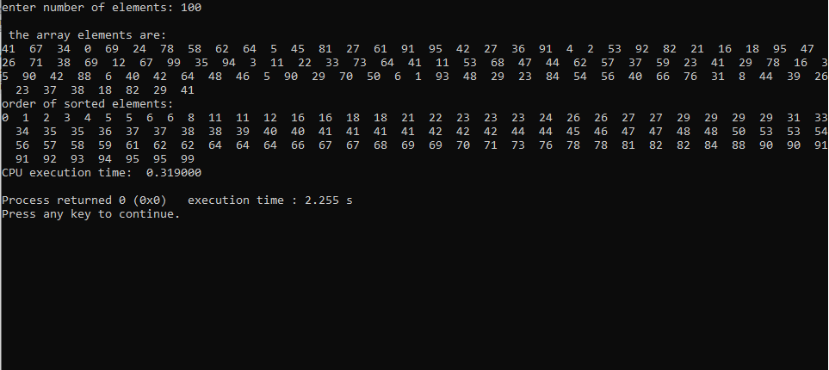

|  |  |
| --- | --- |
| **n** | **t** |
| 100 | 0.315 |
| 200 | 0.951 |
| 300 | 1.691 |
| 400 | 2.79 |
| 500 | 3.918 |
| 600 | 5.273 |